The “double jeopardy” of vulnerable populations
faced with pervasive digital technology

Élodie Alberola, Patricia Croutte and Sandra Hoibian, Centre de Recherche pour l’Étude et l’Observation des Conditions de Vie (CRÉDOC)

For: In Jean-Pierre Dardayrol (ed.) The European digital union [special issue of Réalités Industrielles, August 2016]

Summary:
The European Union’s strategy for a Digital Single Market holds potential for improving living conditions through both consumption (more purchasing power, access to a broader supply of products and services) and the offer of public services (efficiency, fluent procedures, savings, etc.). A real issue in a country, such as France, which ranks well in digital technology (devices and uses), is how to include vulnerable segments of the population so as to keep them from being left stranded along the side of the digital highway. Personalized assistance by physical persons is indispensable to avoid aggravating the individual and social problems of vulnerable groups (the elderly, disabled, chronically ill, recipients of basic public allowances, rural dwellers).

Public authorities sponsor the race toward digital services

Public policies increasingly favor, attend to and support the trend toward digitization in Western societies. They present it as a lever for economic growth and job creation, and as a means for rationalizing and streamlining public finances and improving the citizenry’s well-being. The strategy for a Digital Single Market thus figures among the European Commission’s ten priorities, the ambition being to position Europe as a world leader in the digital economy. It seeks, in particular, to see to it that a similar type of access to the digital infrastructure, along with on-line services and offers, should be provided to individuals and firms alike.
Several benefits are expected. In the first place, potential gains for consumers. Thanks to the Internet and new service platforms, households benefit from a wider variety of goods and services, have access to niche offers (which make it easier to profit from threshold effects), gain purchasing power thanks to greater competition, etc. The Internet along with, more broadly, information and communication technology, is to improve the efficiency, fluidity and reactivity of public services in response to citizens’ needs.

Some pundits see this technology as a lever for reducing costs; others, as a way to alleviate the difficulties experienced by groups to whom we shall refer as “fragile” or “vulnerable”, namely: the elderly, the disabled, the chronically ill, the recipients of basic welfare allowances and rural dwellers. Digital technology is sometimes presented as sparing legwork to the least mobile — the elderly and disabled as well as rural dwellers who live far from administrative centers. It is to be a tool for making paperwork easier and waiting times shorter, for centralizing and optimizing the management of data and information, etc.
But in reality? Does the “dematerialization” of the economy respond to the needs of all consumers and citizens, in particular those who are vulnerable for economic or geographic reasons or owing to their state of health? To answer this question, we shall focus on the French case.
France tends to be a “model” in Europe. It stands near the top of a European ranking by proportion of cybernauts in the population: 84% of Internet users (people from 16 to 74 years old). It ranks sixth on this criterion; some Scandinavian lands, the Netherlands and Luxembourg do better. Furthermore, a large number of people in France shop on line (nine points more than the European average) and communicate on line with public authorities (63% vs. the EU average of 46%). According to the French public administration, 41% of income tax declarations are filed on line, 58% of the quarterly RSA declarations (for drawing a minimum revenue allocation), 33% of requests for housing assistance, 42% of enrollments at the Unemployment Office and 10% of requests for registry certificates. According to FEVAD, an e-business group (Fédération de l’E-Commerce et de la Vente à Distance), on-line sales have experienced two digit growth year after year.

Percentage of Internet users in Europe in 2015  Cybernauts | Percentage of people who made on-line purchases (goods or services: books, music, vacations, etc.) in Europe in 2015  On-line purchases | Percentage of people who contacted public authorities on line in Europe in 2015  Contacts with the public administration
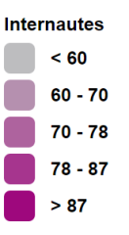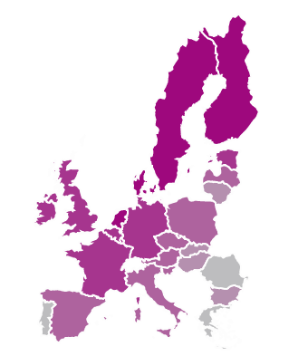 | 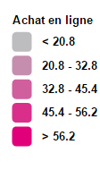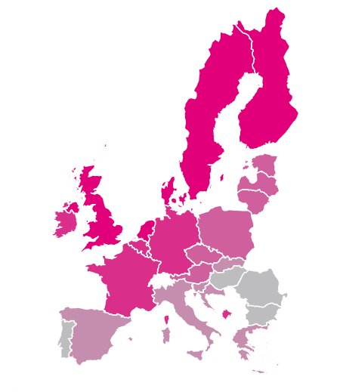 | 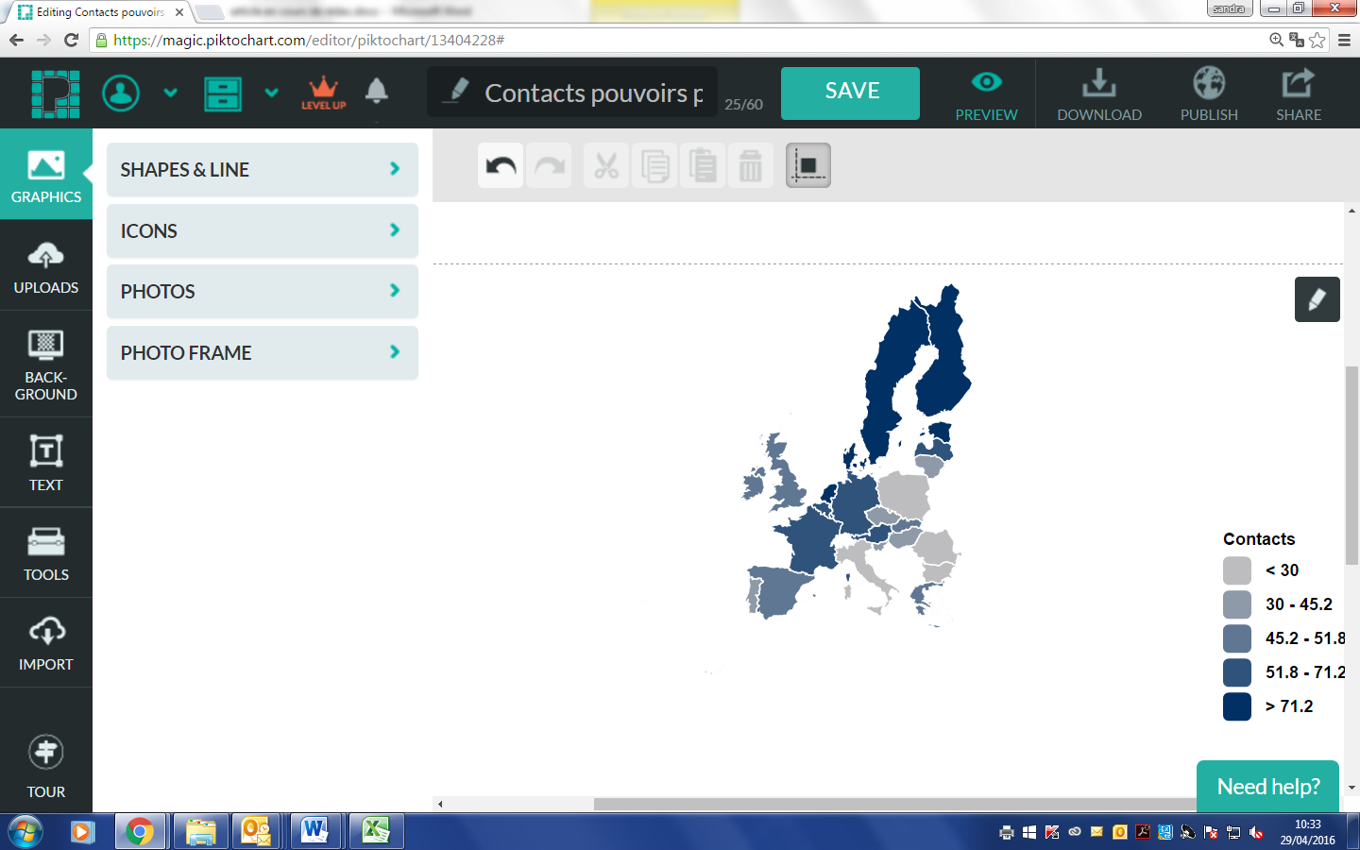
Source: European Commission, 2015, Eurobarometer 423. | Source: European Commission, 2015, Eurobarometer 423. | Source : Eurostat 2015.

Graph 1: France, a model in the EU, with respect to digital equipment and its uses

Categories of the population stranded along the digital highway

In general, the “digital divide” is lessening in France. Differences between people in terms of electronic equipment (computers, Internet access, mobile devices) have been cut in half during a ten-year period. In 2016, according to CRÉDOC’s survey on living conditions and expectations, fewer than one out of five people do not have access to the Internet at home. This proportion rose to: one out of two among people 70 years old and older (51%); 36% of beneficiaries of basic welfare allowances; 27% of persons suffering from a handicap or chronic illness; 26% of rural dwellers; and 26% of persons on a low income.

The CRÉDOC Survey on Living Conditions and Aspirations

CRÉDOC has standing arrangements for studying the French population’s living conditions and aspirations. The survey Conditions de vie et aspirations has been conducted every year since 1978. It has several themes related to well-being and the quality life: material living conditions (household appliances, housing conditions, environment); access to technological and digital equipment; economic morale and expectations for the future; access to culture, leisure activities and vacations; worries and concerns, perceived state of health, etc. It also takes into account several noneconomic aspects, such as social bonds (friends, family, involvement in nonprofit organizations).
The survey is carried out face-to-face with a representative sample of two thousand people (18 years old and older). Another round of the survey (including in France’s overseas departments) takes place on line with a representative sample of three thousand people (15 years old and older).
These two samples are selected using a quota method: distribution of the sample by zone (ZEAT, zone d'étude et d'aménagement du territoire: the nine large geographical zones defined by the French National Institute of Statistics and Economic Studies (Institut National de la Statistique et des Études Économiques: INSÉÉ), by size of urban unit (nine possibilities), by sex, by age (six possibilities) and by socioeconomic status (twelve possibilities). The quotas are set using the latest statistics (census, monthly reports and employment surveys) updated by INSÉÉ. A final rectification of the sample makes sure that it represents the population 18 years old and older.
This methodology allows for tracking changes in opinions over a long period — for nearly forty years now.

As the population has become better equipped (computers, Internet access, high-speed connections, etc.), new forms of equipment are invented. New digital divides thus appear. For instance, the population splits into two groups depending on whether people have (58%) or do not have a smartphone. Very few (35%) have tablet computers. Nomadic devices, now the gateway to new services and offers, are very unevenly distributed: only 15% of people 70 years old and older have a smartphone as compared with 90% of 18-24 year-olds.

18-24 year-olds
inhabitants
of the greater Paris area
25-39 year-olds
high-income persons
recipients
of basic welfare allowances
the general population (18 years old and older)
rural dwellers
the disabled and
chronically
ill
70 years old and older

Graph 2: The ever shifting digital divide: Percentage of people with a smartphone in France in 2015

Source: Baromètre du numérique, a CRÉDOC report for the Conseil Général de l’Économie et L’Autorité de Régulation des Communications Électroniques et des Postes (ARCEP). Available at:
http://www.economie.gouv.fr/files/files/directions_services/cge/Actualites/2015_11_27_barometre-numerique-2015.pdf

Moving beyond the question of equipment, we notice an uneven distribution of the ways of appropriating the new technology and its uses — what has been called “digital literacy”. The OECD has defined this literacy as the aptitude to understand and use such technology in everyday life, at home, at work and in society (whether for personal reasons or for improving skills and qualifications). As the National Digital Council has pointed out, each of us is now in an ongoing situation of learning and self-appraisal given the constant development of digital tools and uses. This appropriation requires more effort as innovations are continually being invented at a faster rate. Whereas computers took nearly fifteen years to enter half of French households, smartphones reached this proportion in four years.
Some groups have trouble keeping apace. Very few people over 70 make purchases or accomplish administrative or fiscal formalities on line. The inhabitants of rural areas, to whom digital technology promised an easier life, are fewer than the inhabitants of the greater Paris area to make purchases or accomplish formalities on line. The disabled and chronically ill also appropriate the new technology less than other groups; and as much can be said about the recipients of basic welfare allowances.

On-line purchases in France in 2016 | Administrative and fiscal formalities accomplished on line in France in 2016
57% of people 18 years old and older have made an on-line purchase during the last twelve months. | 57% of people 18 years old and older have accomplished administrative formalities on line during the last twelve months.

Source: CRÉDOC, data from Baromètre du numérique and CRÉDOC, Enquête: Conditions de vie et aspirations.

Graph 3: An uneven diffusion of uses of the Internet among certain categories of the population

The paradox of digitizing welfare

Welfare programs — set up to attend to the cases of the potentially vulnerable — have been swept up in the digitization trend. Dematerialization entails shaping and rationalizing offers, a process that tends to be incompatible with the complex, uneven (in fact, atypical) backgrounds of the vulnerable who lack digital literacy. As Geneviève Koubi has emphasized, making information or services available on line does not mean they will be used appropriately. The difficulty of searching for information on line and of handling it is a reason why the most vulnerable do not claim benefits for which they are eligible. An institutional tendency, widely shared by a range of public services, is to use the new technology to rationalize the management of offers but without actually taking into account the fact that requests or needs cannot always be standardized.
Besides having access to the Internet, users must find their way through websites while managing several logins and passwords. There are stumbling blocks strewn everywhere in the paths of people wending over the web. Some of the vulnerable, in particular the elderly, have a mental block. In 2013, 87% of people over the age of 70 declared they felt incapable of using a computer. The percentage was less (but not negligible) among rural dwellers (55%) and the disabled or chronically ill (62%).

CAFs and digitization

Since March 2014, the website of the Caisse Nationale d’Allocations Familiales (CNAF), which federates family allowance funds (caisses d’allocations familiales, CAF), has a mobile application for managing and following up on users’ cases (“Caf-mon compte” on http://www.caf.fr). In August 2015, 2,040,116 mobile applications were downloaded. Thanks to this application, beneficiaries of family allocations can check their personal data and, if need be, modify them. When browsing their historical data (covering the last 24 months), they have access to information about the last ten payments made. They can also download to their mobile telephones PDF-documents with their account statements and certificates.
According to CNAF’s last user satisfaction poll, the website is the channel most frequently used by beneficiaries for contacts: 60% who had contacted their CAF said they did so via the website. To promote this offer of dematerialized services, the CAFs adopted procedures for the (physical) reception of beneficiaries Multi-service “spaces” have been set up to make beneficiaries more autonomous by proposing self-service computer terminals and thanks to the assistance given by receptionists. The receptionists may also orient the public toward “digital spaces” open to the public: Emmaüs Connect, Pimms, Points Relais, social SVD centers, etc.

Source: CNAF

Designing digitized public services to avoid “double jeopardy”

Some groups have to be closely accompanied lest the new technology make it harder for them to be socioeconomically integrated or to have the administrative autonomy indispensable for obtaining benefits. Among the various improvements of services proposed by French family allocation funds (CAFs) to beneficiaries in 2014, the need for human “mediation” was deemed much more important than the accomplishment of all formalities on line. Furthermore, this expectation for human support was higher among the disabled, people over 70 and rural dwellers.

Graph 4: Vulnerable groups: The expectation of human assistance

Which of the following services would you want your CAF to propose in priority? Total for each of the two responses among the following: personalized follow-up; counselors capable of helping with other formalities; regular information on your situation; the possibility of accomplishing all formalities via the Internet; more simulations of benefits.

Rural areas
Suffer from a handicap
70 years old and older
Counselors capable of helping with other formalities
Accomplish all formalities on the Internet
Source: CRÉDOC, Enquête: Conditions de vie et aspirations pour la CNAF, 2014.

Vulnerability, unemployment, isolation (in the broadest sense of the word) are aggravated by the lack of digital literacy and experience. The dematerialization of procedures for applying for benefits makes it even harder for the vulnerable to maintain contact with institutions and, ultimately, draw benefits. The recent complete digitization of formalities for applying for a special allowance (prime d’activité) is evidence of this. Applications can be filed only on line; and simulations of the benefits to be delivered are available only on line. Opening a personal account is already a laborious first step, a prerequirement imposed on individuals who might be disoriented when coping with an urgent situation and who have difficulty in dealing with the administration (need to memorize codes, store data, etc.).
Daniel Thierry has analyzed how the process of depersonalizing contacts and standardizing procedures for handling applications has, among its effects, the failure to use such procedures and apply for benefits. He has pointed to the pressure on applicants asking for welfare benefits: they are summoned to be digitally autonomous. This reinforces a selection based on individual aptitudes and a process of social disqualification.
Illiteracy, age differences, language problems, disabilities, and complicated social situations are factors that produce “digital dropouts”. The trend in public administration toward a digitization of all procedures must provide for a personalized followup to persons outside the system. The purpose should be to avoid exacerbating their social and administrative problems and ultimately creating another form of social disqualification.

This article has been translated from French by Noal Mellott (Omaha Beach, France). References have been updated for this translation.
http://ec.europa.eu/priorities/digital-single-market_en
The notion of “fragility/vulnerability” is taken in its broadest sense. Article L.241-10 of the French Social Security Code defines people 70 years old or older (whether dependent or not) and the dependent (who receive basic welfare benefits under programs for the disabled, the frail elderly, etc.) as “fragile”. Over the past decades, this concept has passed into social science studies of the labor market, employment, poverty and vulnerability. According to Chambers (1989: "Vulnerability, coping and policy”, IDS Bulletin, University of Sussex, 20(2), pp.1-7), vulnerability is a concept of statistical probability expressing an individual’s proximity to harm or injury.
European Commission, Cyber security report (Special Eurobarometer 423), February 2015, available at: http://ec.europa.eu/public_opinion/archives/ebs/ebs_423_en.pdf
See §Internet Usage in “Digital economy and society statistics - households and individuals”, Eurostat, data extracted in June 2015. Available at: http://ec.europa.eu/eurostat/statistics-explained/index.php/Information_society_statistics_-_households_and_individuals
“Tableau de bord des services publics numériques”, 7 October 2015: http://www.modernisation.gouv.fr/ladministration-change-avec-le-numerique/par-des-services-numeriques-aux-usagers/tableau-de-bord-des-services-publics-numeriques-2015
Régos Bigot & Patricia Croutte, La diffusion des technologies de l’information et de la communication dans la société française (2014): Étude réalisée à la demande du Conseil Général de l’Économie, de l’Industrie, de l’Énergie et des Technologies (CGE) et de l’Autorité de Régulation des Communications Électroniques et des Postes (ARCEP), CRÉDOC: Collection des Rapports, November 2014. Available at: http://www.credoc.fr/pdf/Rapp/R317.pdf
Geneviève Koubi, “Services en ligne et droits sociaux”, Informations sociales, 178, pp.44-51, 2013/2014.
Sandra Hoibian, along with Patricia Croutte and Régis Bigot (scientific supervisor), Soutien à la fonction parentale, connaissance des dispositifs et perception de la CAF. État de l’opinion en 2014, CRÉDOC: Collection des Rapports, 310, July 2014. Available at: http://www.credoc.fr/pdf/Rapp/R310.pdf
Emmaüs Connect, “La numérisation facteur d’exclusion pour ceux qui cumulent précarité sociale et numérique”, Le Monde, 4 July 2016. Available at: http://www.lemonde.fr/idees/article/2016/04/07/la-numerisation-facteur-d-exclusion-pour-ceux-qui-cumulentprecarite-sociale-et-numerique_4897781_3232.html
Daniel Thierry, “Rationalisation de l’offre par les technologies: un facteur supplémentaire de non-recours. L’exemple des visio-guichets de service public” in Actes du colloque “Le non-recours en débat: expériences et usages des droits et des services sociaux parmi les professionnels et les ayants droit”, Université d’Angers, December 2013.

